At North Kansas City Schools, well-being is more than just a number, it is living the best life. Health data is one helpful way to gage how the body is functioning and a way to support living your best life.

It is always recommended that you consult your physician before making lifestyle changes.

Cholesterol
Cholesterol is a fat in the blood stream that is carried around by lipoproteins and is used to build cells. The liver in the body produces cholesterol but cholesterol comes from the diet, specifically animal foods. Cholesterol has three types of fats in the blood stream, low-density lipoprotein (LDL) cholesterol, high-density lipoprotein (HDL) and triglycerides. Having a combination of high LDL cholesterol or low HDL cholesterol and high triglycerides in the bloodstream can be a problem as it can build up and increase the chances of heart disease.

If you have concerns with your cholesterol levels, discuss with your physician. Maintaining healthy ranges supports your heart health.

 | Total Cholesterol | Triglycerides | Low-Density Lipoprotein (LDL) | High-Density Lipoprotein (HDL)
Low Risk | Below 200 | Below 150 | Below 130 | Above 59
Moderate  Risk | 200-239 | 150-199 | 130-159 | 40-59
High  Risk | Above 239 | Above 199 | Above 159 | Below 40
American Heart Association

Blood Pressure
When your blood pressure is taken, there are two numbers, systolic and diastolic blood pressure. The systolic blood pressure is the upper number that indicates the pressure your blood is exerting against your artery walls as the heart beats. The diastolic blood pressure is the lower number and indicates the pressure your blood is exerting against your artery walls while the heart is resting between beats.

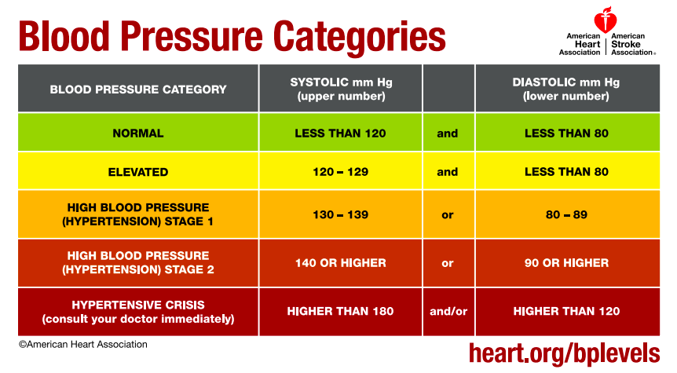

Glucose
The body produces a hormone called insulin to remove glucose or sugar from the body after food is consumed. When the body does not use insulin properly, that is called insulin resistance and the pancreases tries to compensate by creating more insulin to keep blood sugars at normal levels in the body. Overtime the pancreas cannot keep up and stops creating enough insulin which allows the glucose to rise in the bloodstream. When the blood glucose levels are higher than normal it is called high blood glucose or hyperglycemia.

There are a variety of types of high blood sugar; Prediabetes, Type 1 diabetes, Type 2 diabetes and Gestational diabetes. When a fasted blood sugar is tested, the ideal number is below 99. Anything higher would best be advised to talk with a health care provider.

Weight and BMI
Maintaining a healthy weight not only benefits the way clothes fit but supports a balanced lifestyle. Losing weight or maintaining a healthy weight for your body supports your quality of life including, fewer joint or muscle pain, increased energy and ability to join, better sleep and reduction in developing health risks.

Here are some great tips when it comes to weight loss.
- Eat when you are hungry and stop when your full.
- Drink plenty of water. Aim to drink half your body weight in ounces.
- Move 120 minutes a week and add two days of strength training.
- Be grateful for what your body can do.
- Have a healthier snack on hand for when you need a quick burst of energy.

Web Resources
- American Diabetes Association
- American Heart Association- Blood Pressure
- American Heart Association- Cholesterol
- American Heart Association- Diabetes
- American Heart Association- Healthy Eating
- American Heart Association- Physical Activity
- Centers for Disease and Control- Blood Pressure
- Centers for Disease and Control- Diabetes
- Centers for Disease and Control- Healthy Weight
- Choose My Plate

